Class Activity - Identify Running Processes

Objectives
In this lab, you will use TCP/UDP Endpoint Viewer, a tool in Sysinternals Suite, to identify any running processes on your computer.
Part 1: Download Windows Sysinternals Suite.
Part 2: Start TCP/UDP Endpoint Viewer.
Part 3: Explore the running processes.
Part 4: Explore a user-started process.

Background / Scenario
In this lab, you will explore processes. Processes are programs or applications in execution. You will explore the processes using Process Explorer in the Windows Sysinternals Suite. You will also start and observe a new process.

Required Resources
- 1 Windows PC with internet access

Instructions

Download Windows Sysinternals Suite.
    - Navigate to the following link to download Windows Sysinternals Suite:
https://technet.microsoft.com/en-us/sysinternals/bb842062.aspx
    - After the download is completed, right+click the zip file, and choose Extract All…, to extract the files from the folder. Choose the default name and destination in the Downloads folder and click Extract.
    - Exit the web browser.

Start TCP/UDP Endpoint Viewer.
    - Navigate to the SysinternalsSuite folder with all the extracted files.
    - Open Tcpview.exe. Accept the Process Explorer License Agreement when prompted. Click Yes to allow this app to make changes to your device.
    - Exit the File Explorer and close all the currently running applications.

Explore the running processes.
    - TCPView lists the process that are currently on your Windows PC. At this time, only Windows processes are running.
    - Double-click lsass.exe.

Question:
What is lsass.exe? In what folder is it located?
Type your answers here.
    - Close the properties window for lsass.exe when done.
    - View the properties for the other running processes.
Note: Not all processes can be queried for properties information.

Explore a user-started process.
    - Open a web browser, such as Microsoft Edge.
What did you observe in the TCPView window?
Type your answers here.
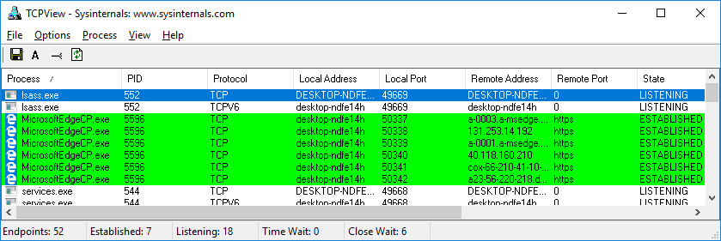
    - Close the web browser.

Question:
What did you observe in the TCPView window?
Type your answers here.
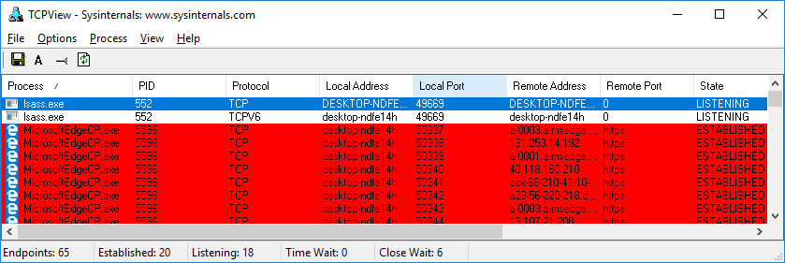
    - Reopen the web browser. Research some of the processes listed in TCPView. Record your findings.

Activity Answers
Part 3:
b.
Isass.exe is a windows process with a Process ID of 1484. It handles the Local Security in windows. On my PC it is located on my C drive where windows is installed in system 32. The path is C:\Windows\System32\lsass.exe on my machine.
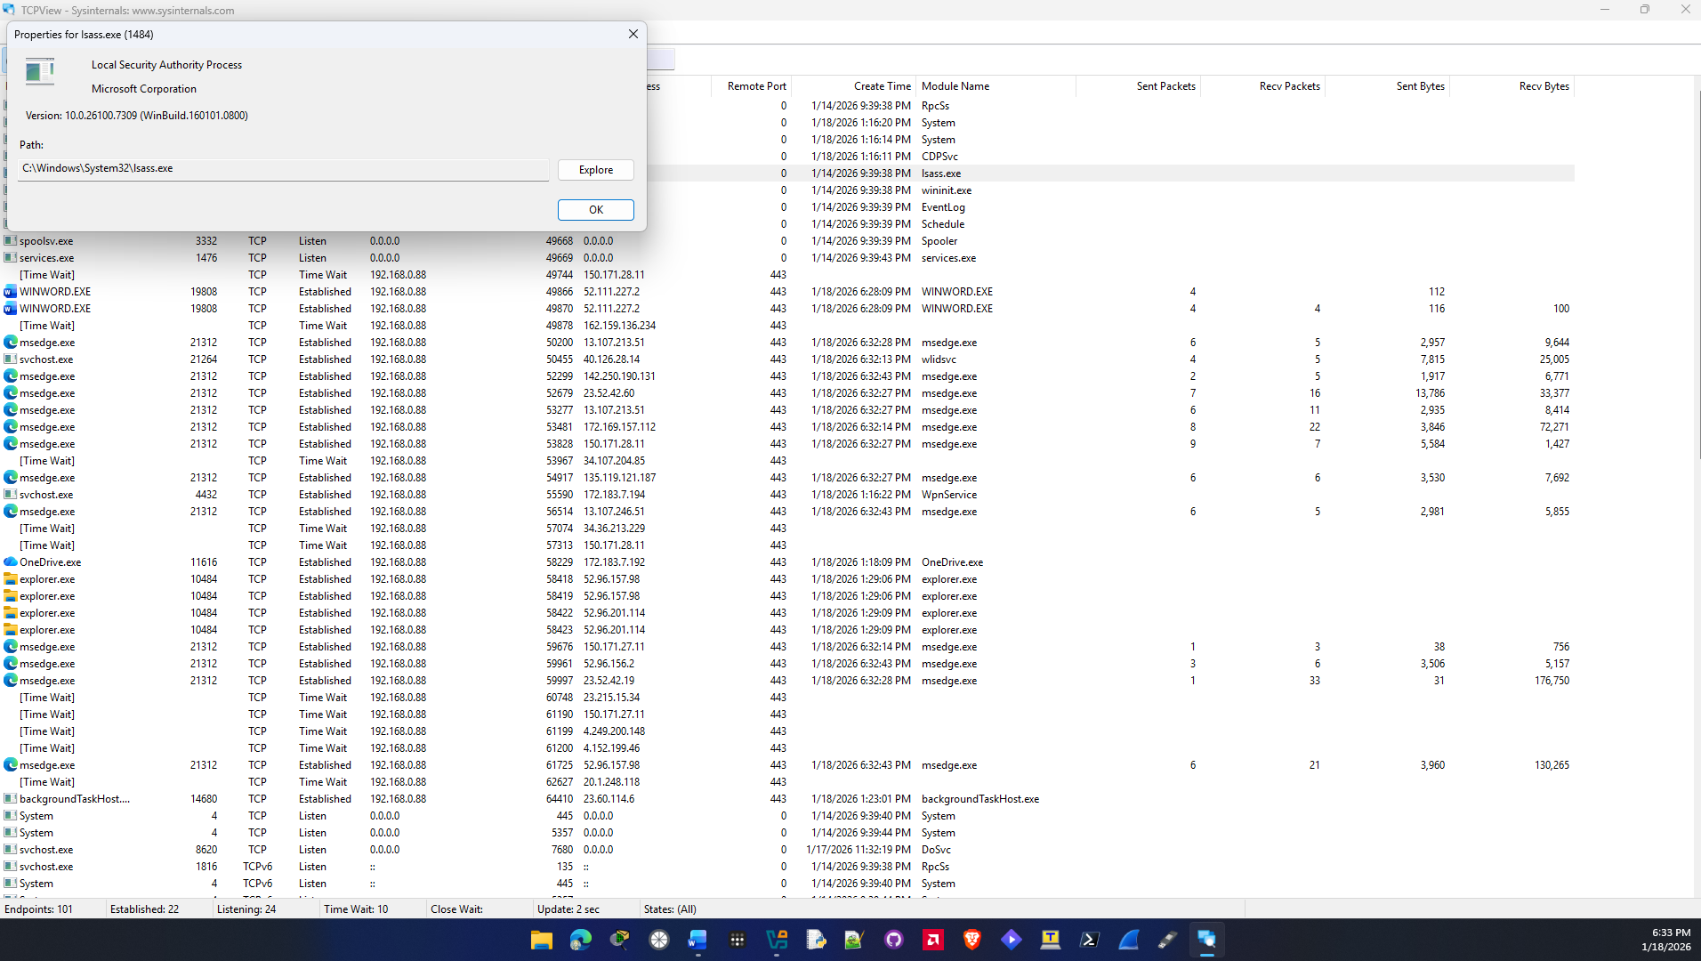

Part 4:
a.
When I opened Microsoft Edge It opened up a bunch of new processes in the TCPView with the process id of 21312. They were also all highlighted green. Green must mean a new process has opened or started. Multiple instances of edge opened up because it looks like it was trying to make a connection at several different remote addresses on different local ports. They made the connection on port 443 which is HTTPS.
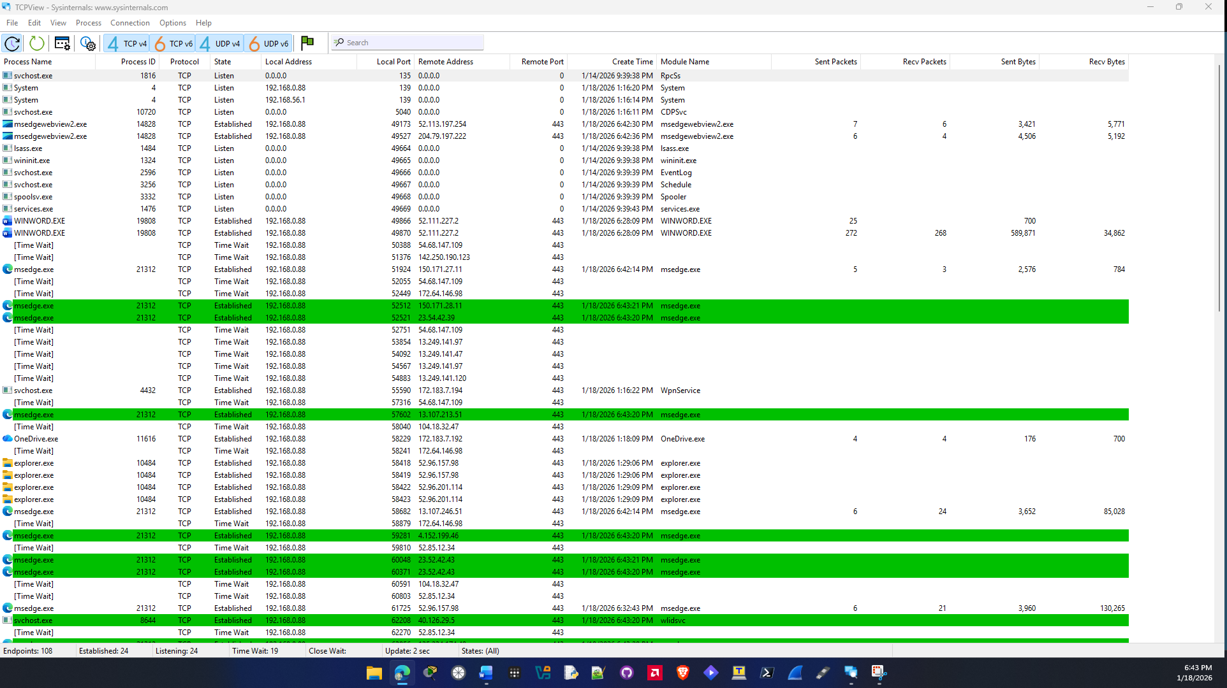

b.
When I closed edge the msedge processes that were open turned red and then disappeared from TCPView. I am assuming this is the process closing or exiting from the processes in the operating system. Although since msedge is integrated in windows multiple processes of it still remained up.
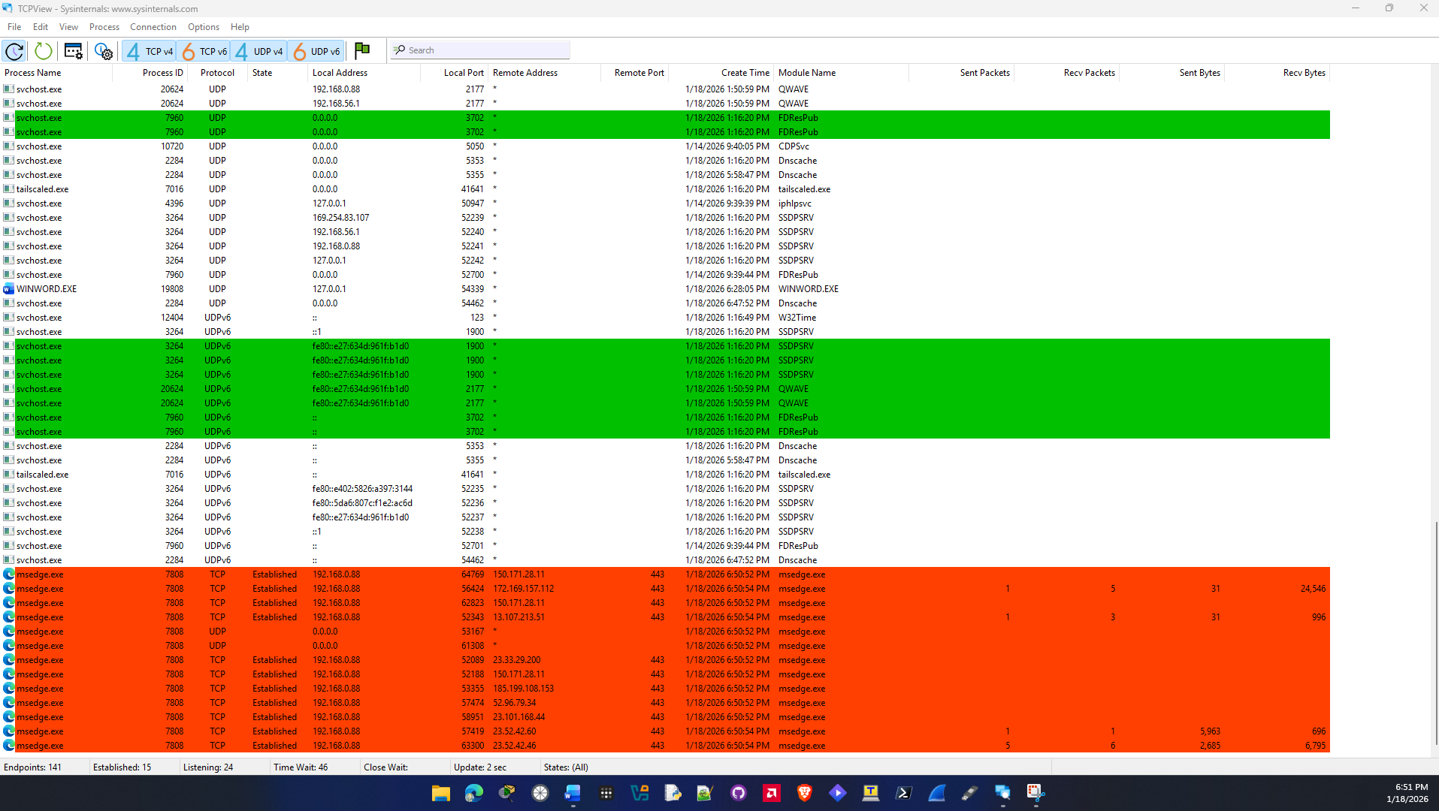

C.
wininit.exe:
Its process id is 1324 and its located in the windows system32 folder on my c drive. The path on my computer is C:\Windows\System32\wininit.exe. It’s used in the initialization process of windows by many programs and other services to startup.
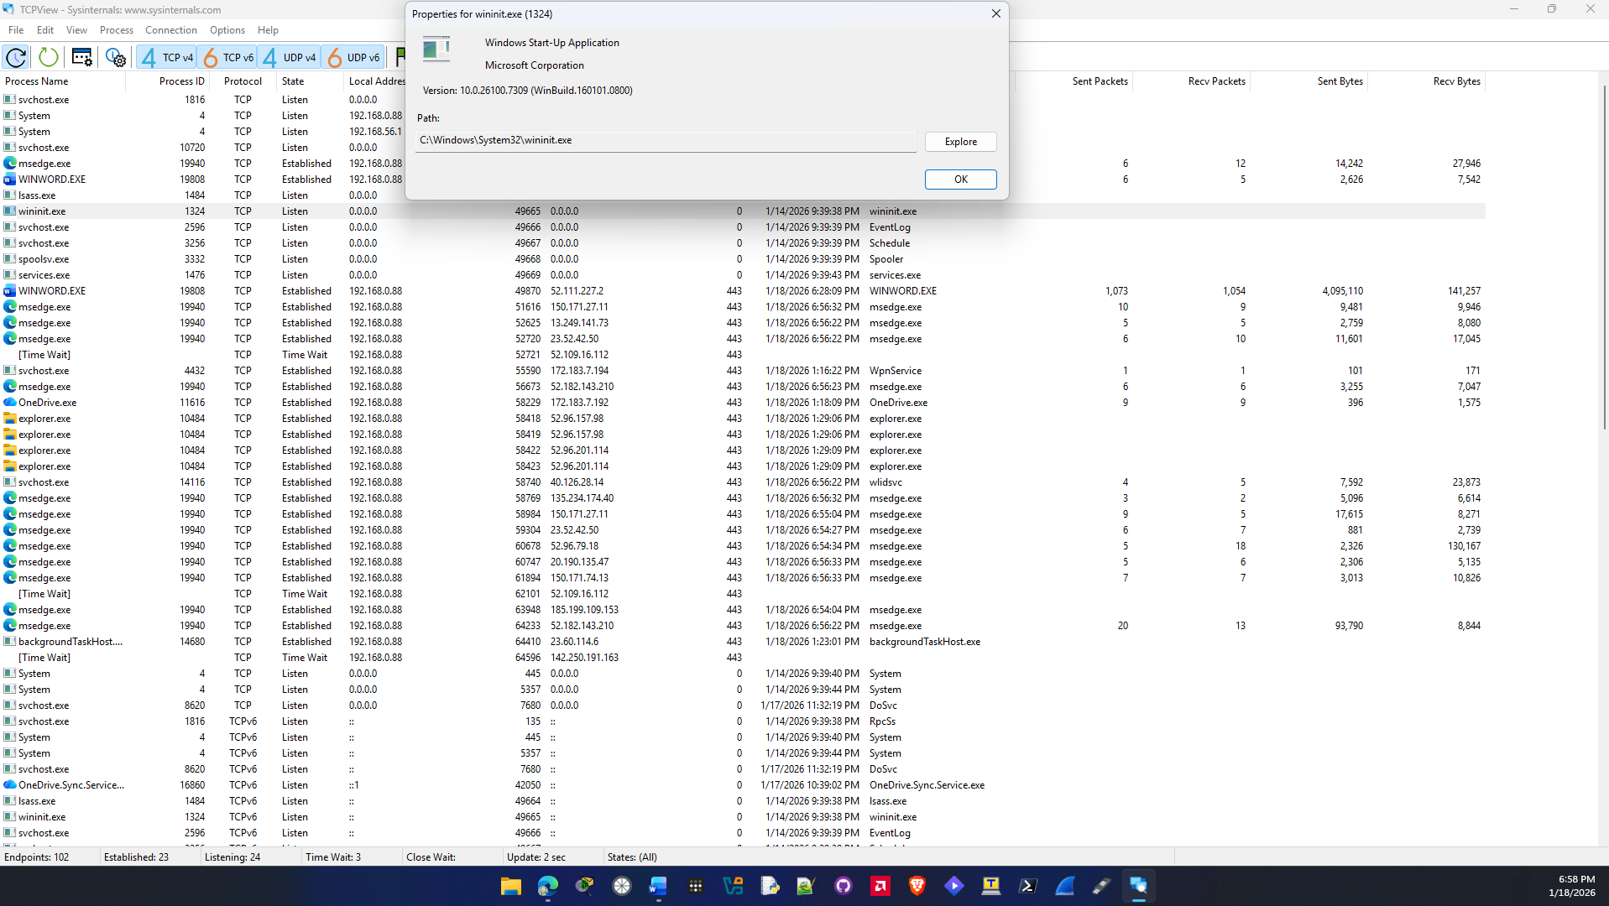

spoolsv.exe:
Its process id is 3332 and it’s another system process located in the system 32 folder. Its path on my pc is C:\Windows\System32\spoolsv.exe. This process is responsible for managing printing and faxing jobs in windows.
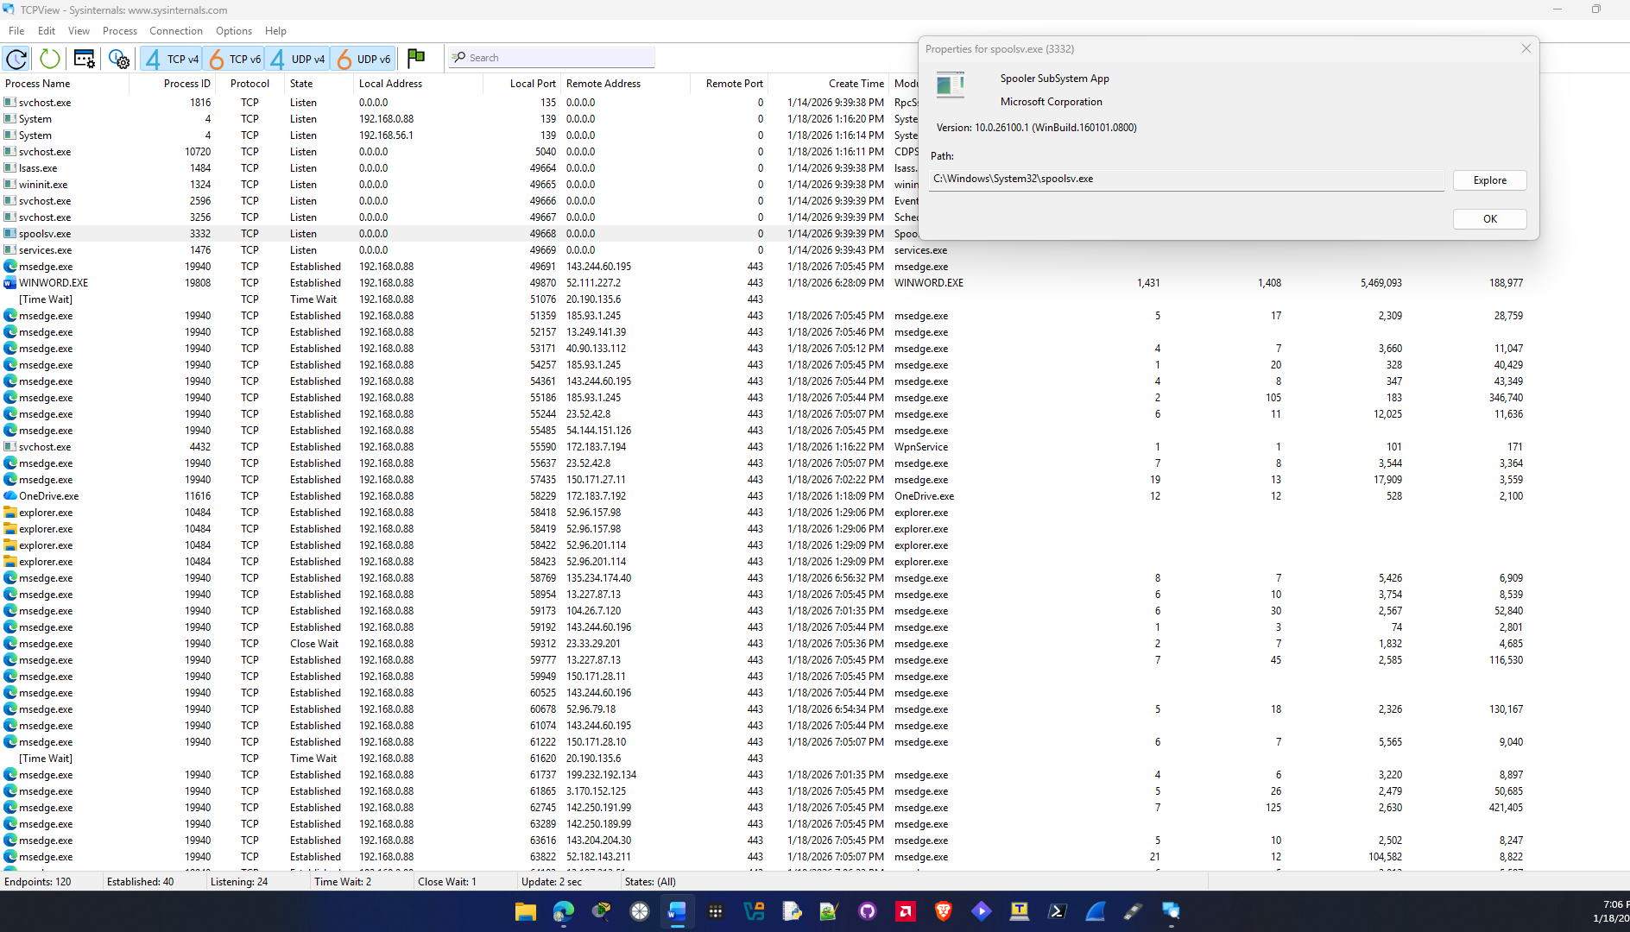

svchost.exe:
It’s another system file and there are multiple processes of it open with differen process IDs. It’s a critical system process and used to describe host services. Windows uses this service to group services that need access to the same DLL to run.
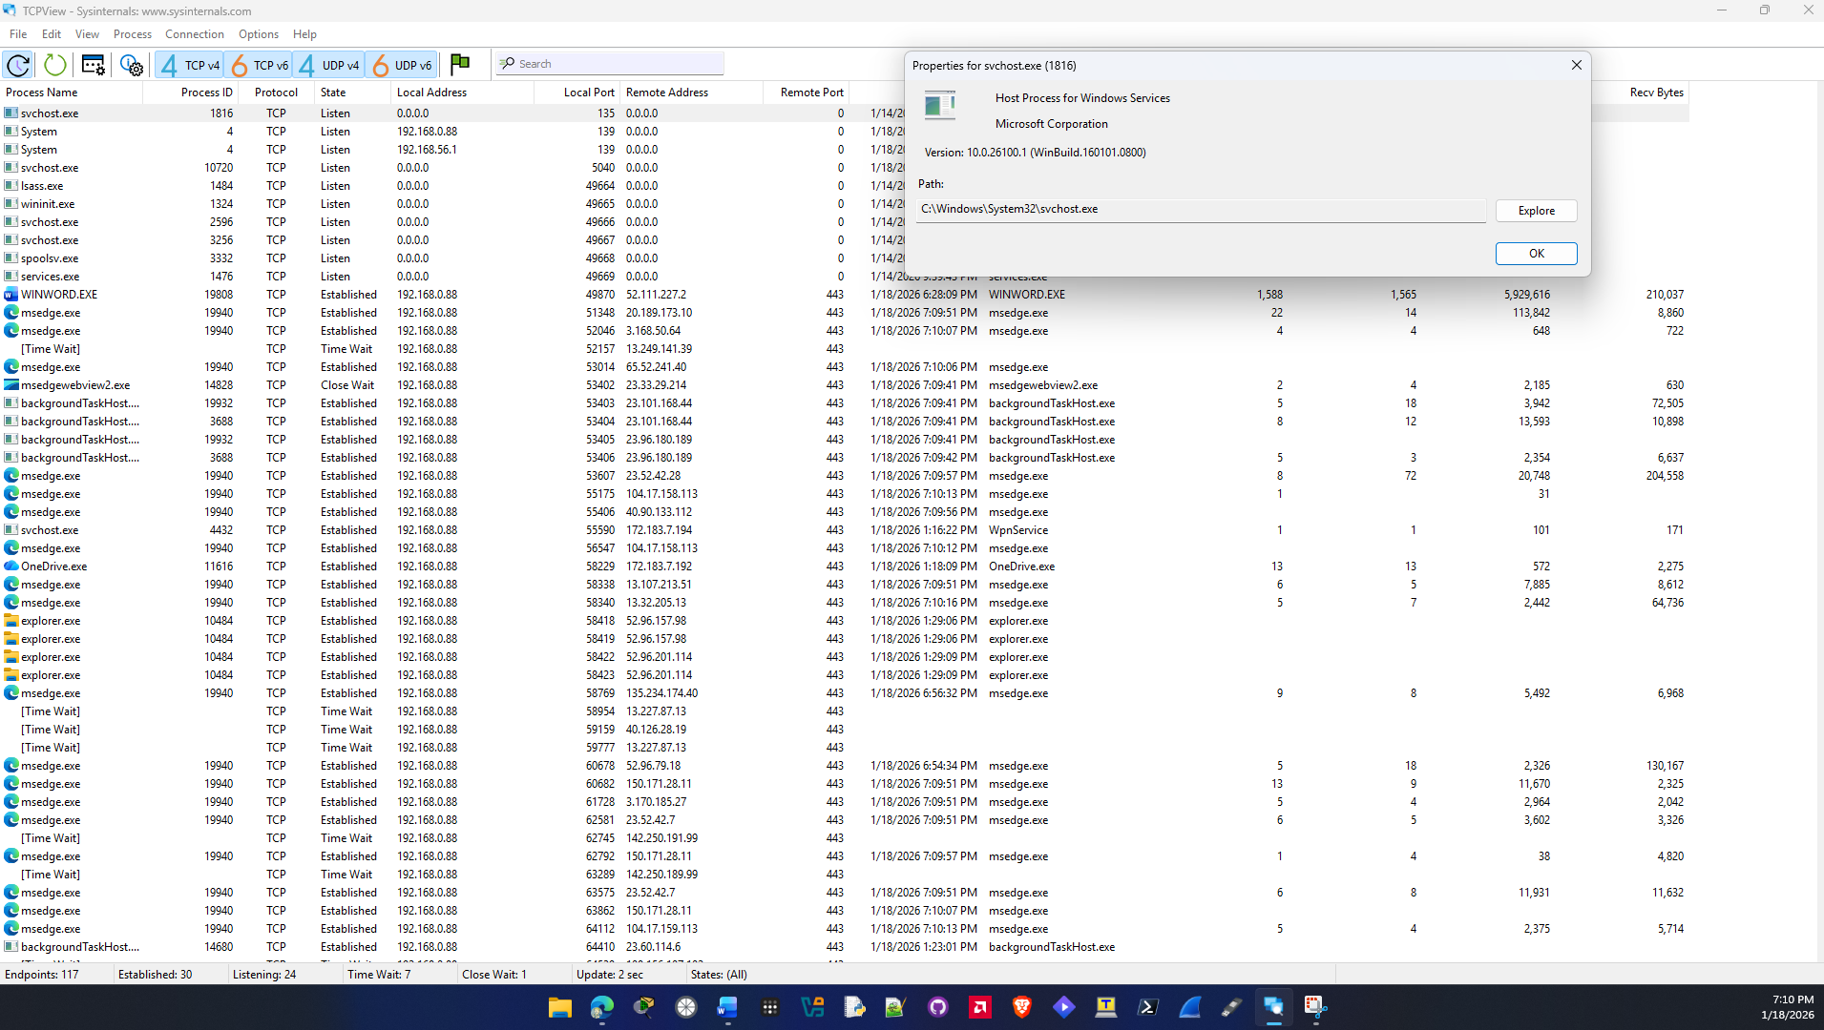

Sources:
https://www.thewindowsclub.com/what-is-wininit-exe-process
https://www.lifewire.com/scvhost-exe-4174462
https://www.howtogeek.com/323332/what-is-spooler-subsystem-app-spoolsv.exe-and-why-is-it-running-on-my-pc/

Type your answers here.
End of document

